INSHORTS ANDROID APPLICATION

Features implemented:

1. **In app web browser**

 With zoom in Enabled

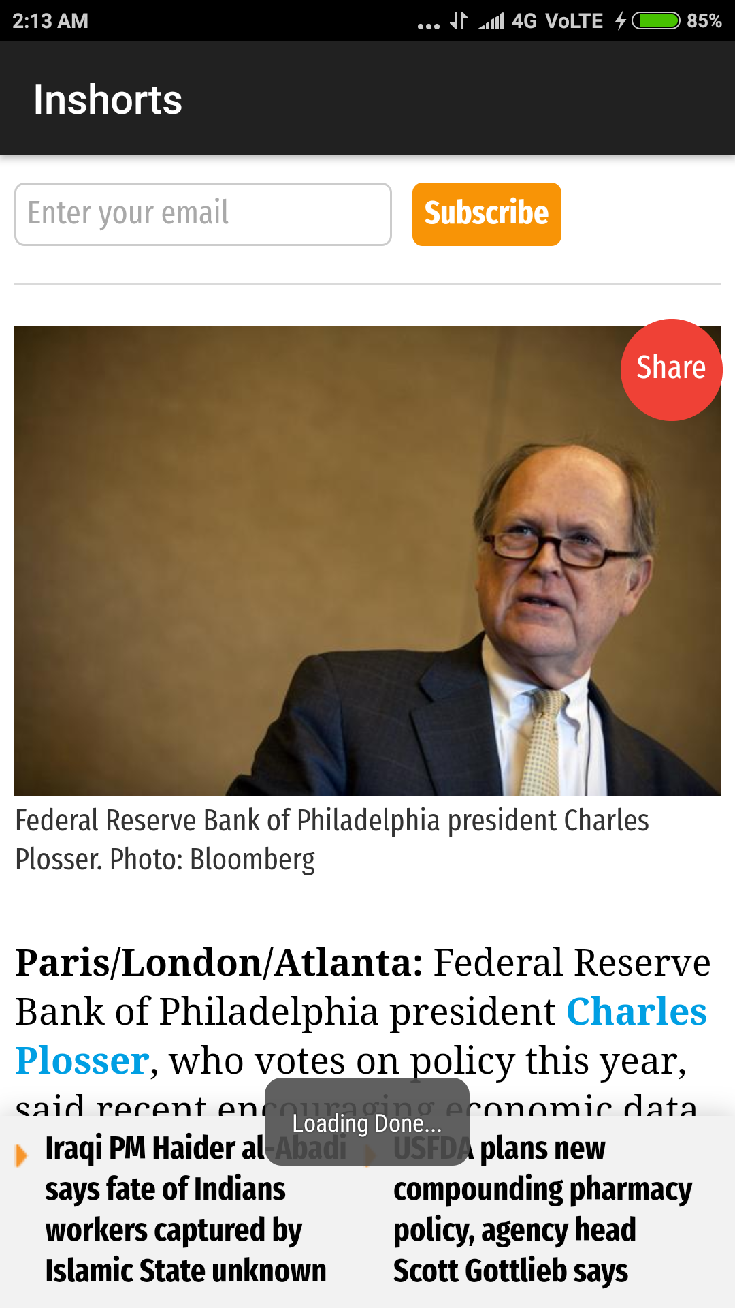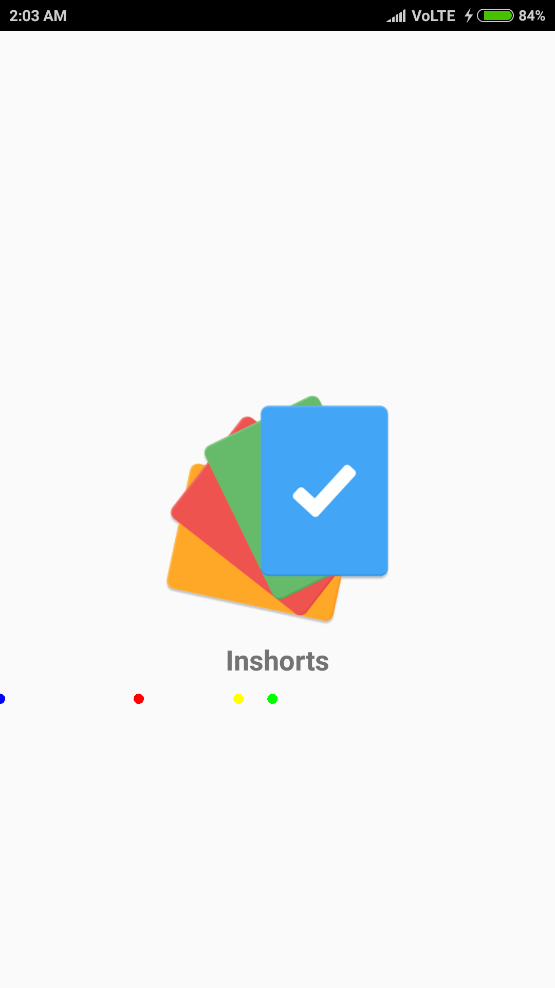

1. **Splash Activity with basic animation**

The colored dots move when activity starts.

(Portfolio activity)

1. **Refreshing of ListView**

The Button at right of the text “Inshorts ” in the SupportActionBar is the refresh button.

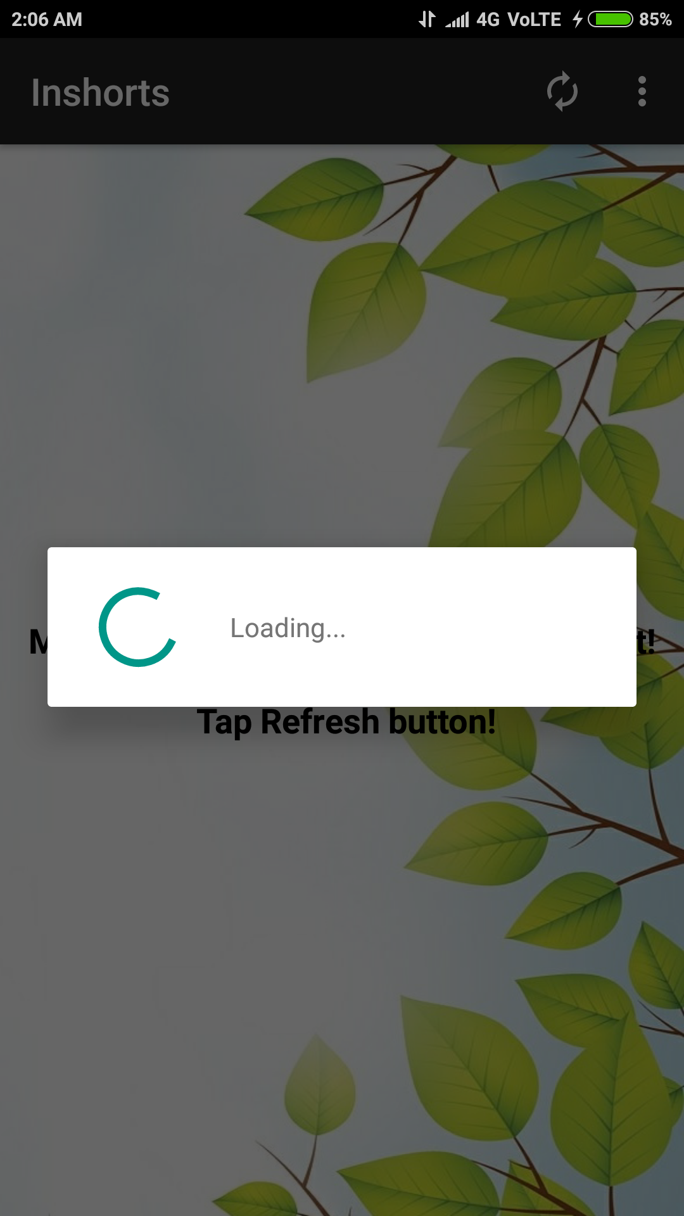

The progress Dialog opens automatically when the app runs for the first time. And also when refreshed is pressed.

If there is no internet connectivity then the Message in the next screenshot is displayed.

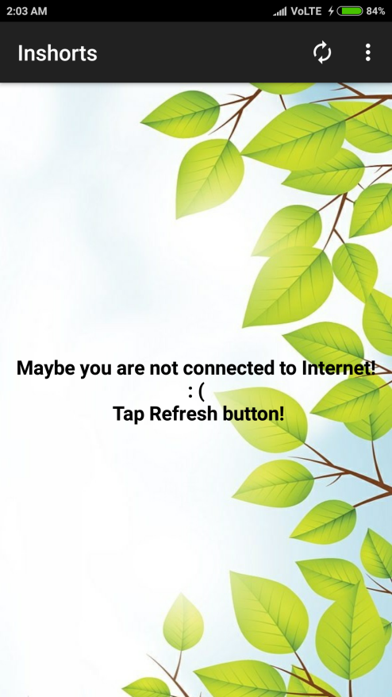

The message displayed is if there is an error wile parsing the JSON object.

If you again connect to the internet and then press the refresh button then the list of news is displayed.

1. **Sorting by date (News), Filter by Category and Publisher**

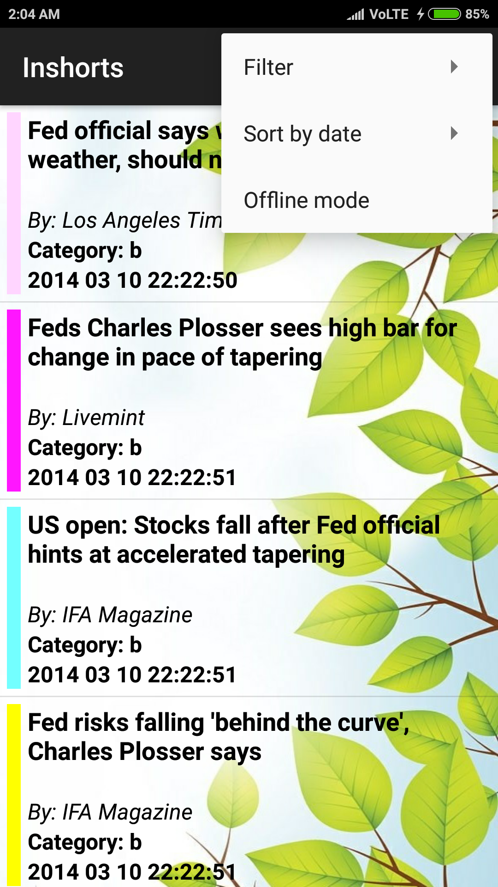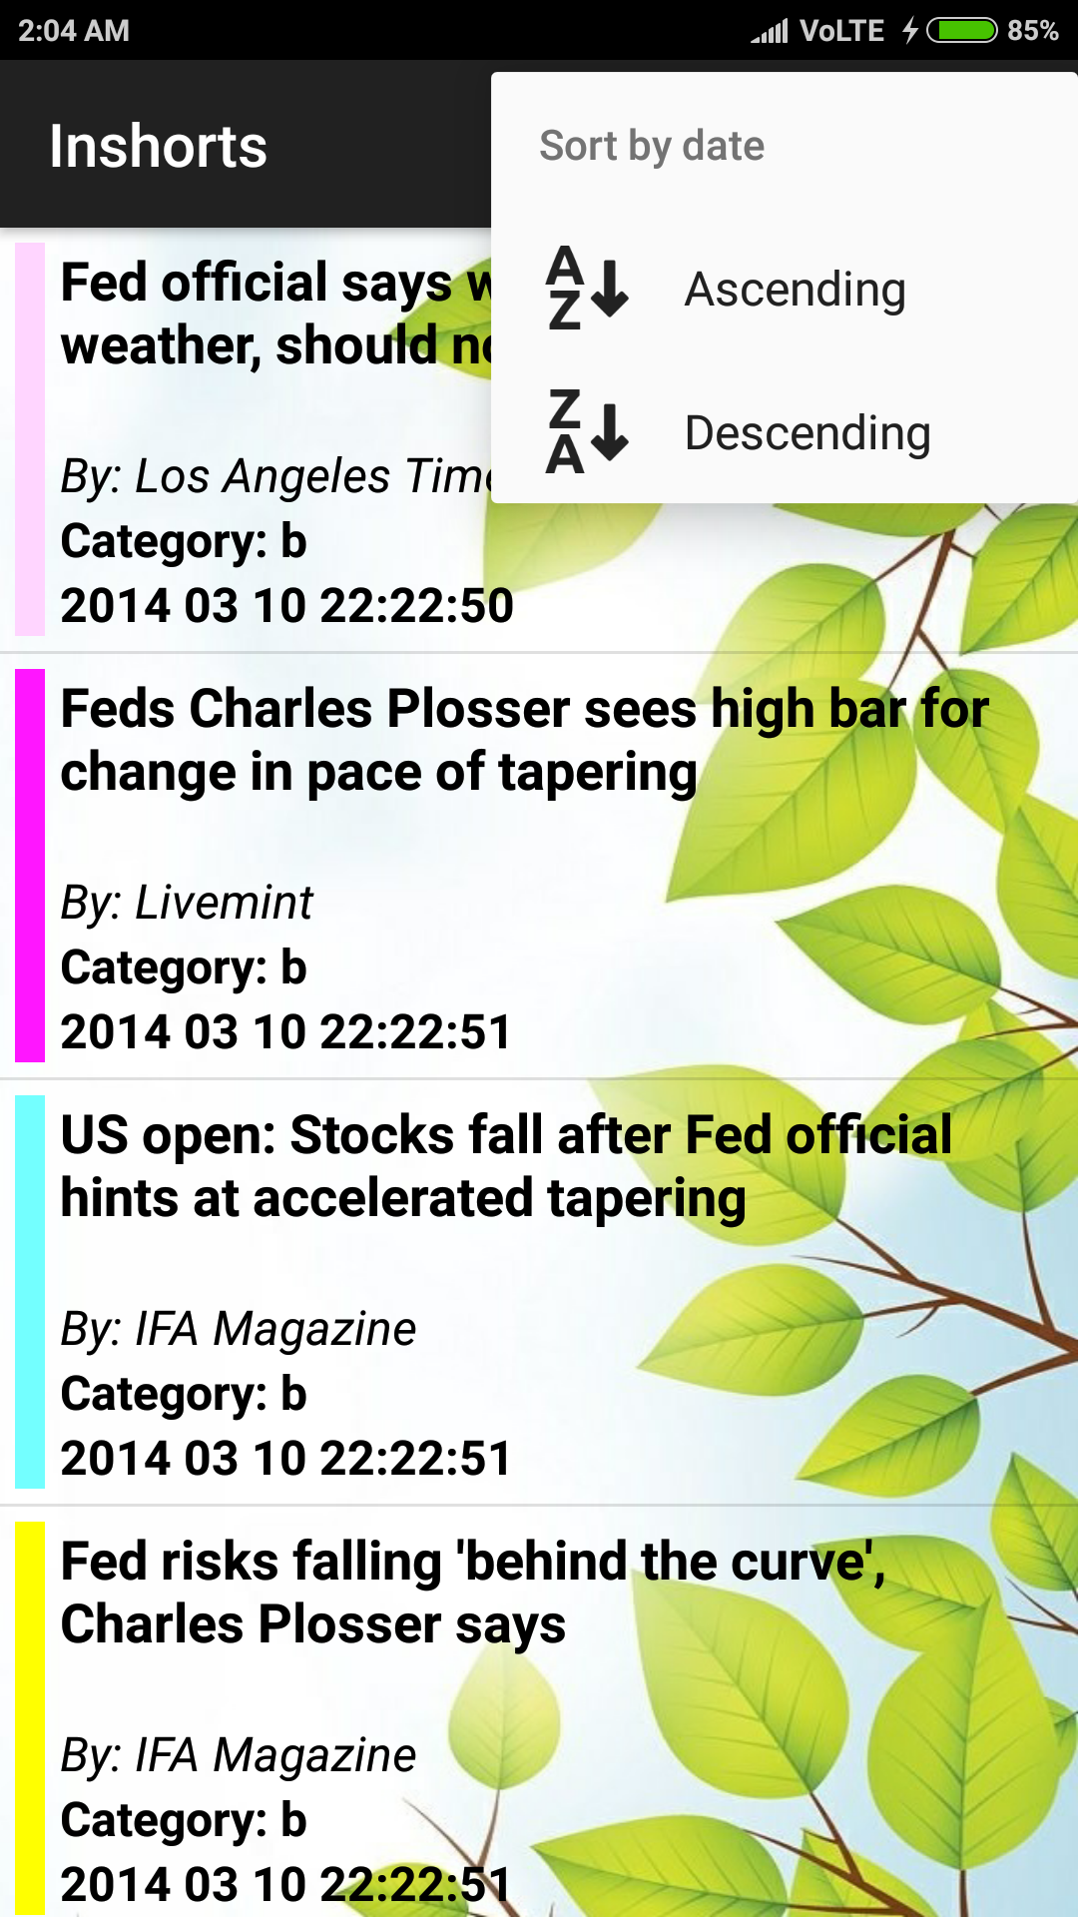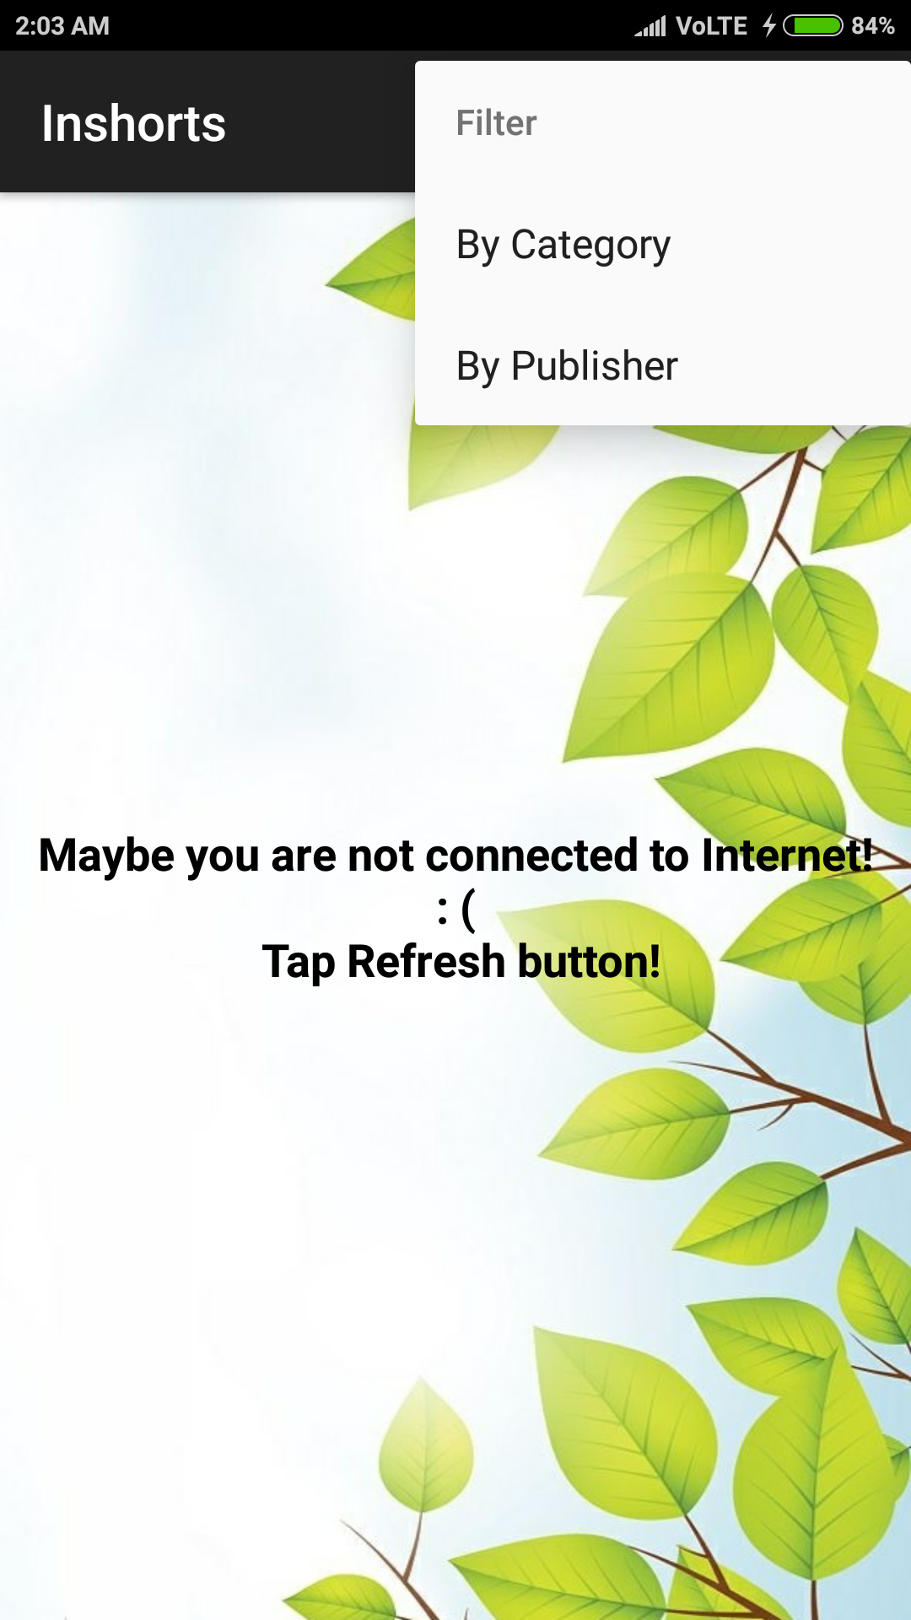

The menu items (“By Category”, “ By Publisher”) when tapped open the Filter Dialogs separate for both filters.

The menu items (“Ascending”, “Descending’) arrange the list items with increasing and descreasing date and time respectively.

The dialog boxes are shown in the next images. They have spinners to make the selection.

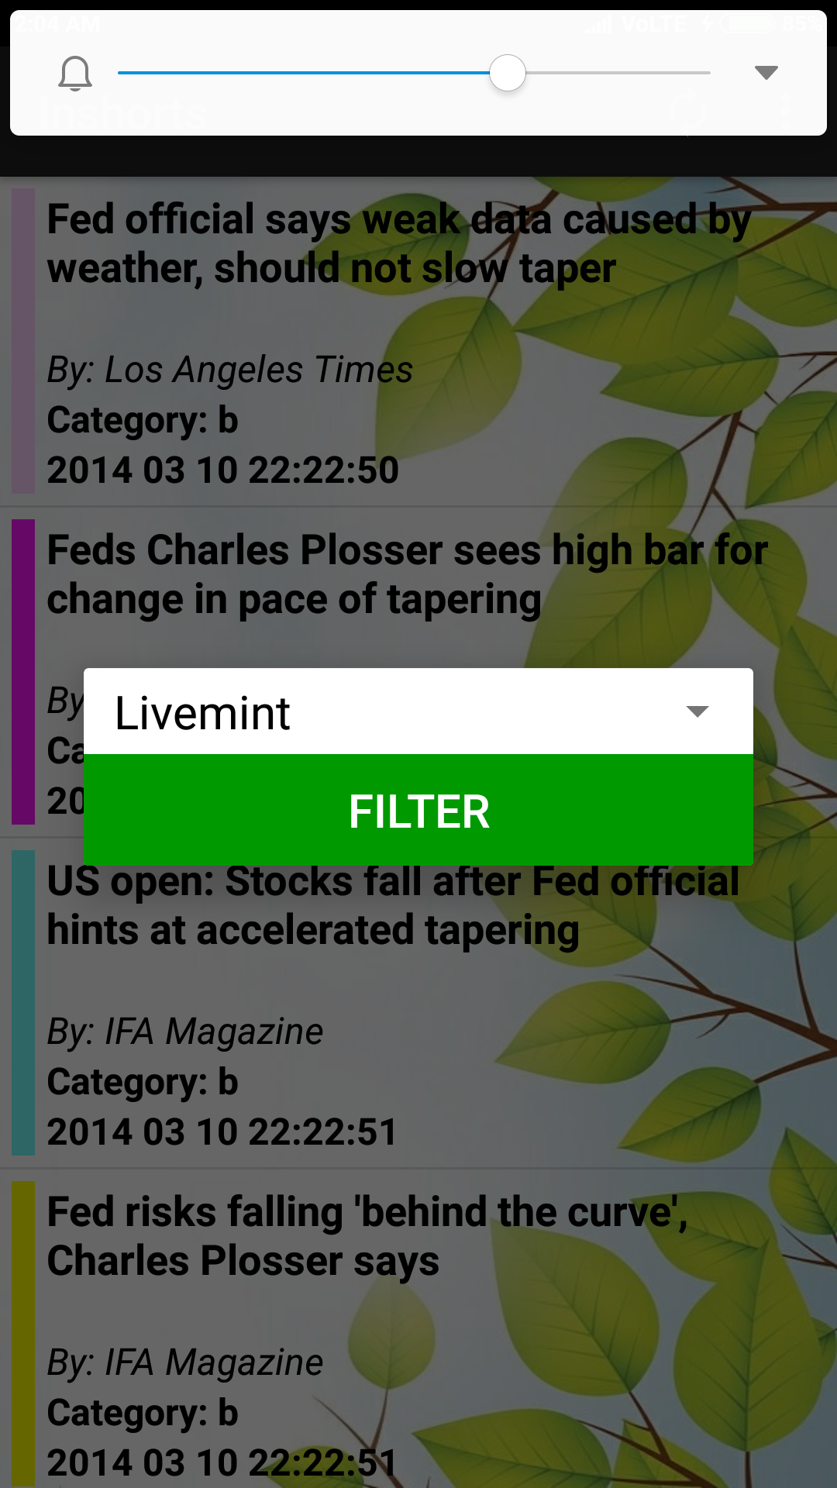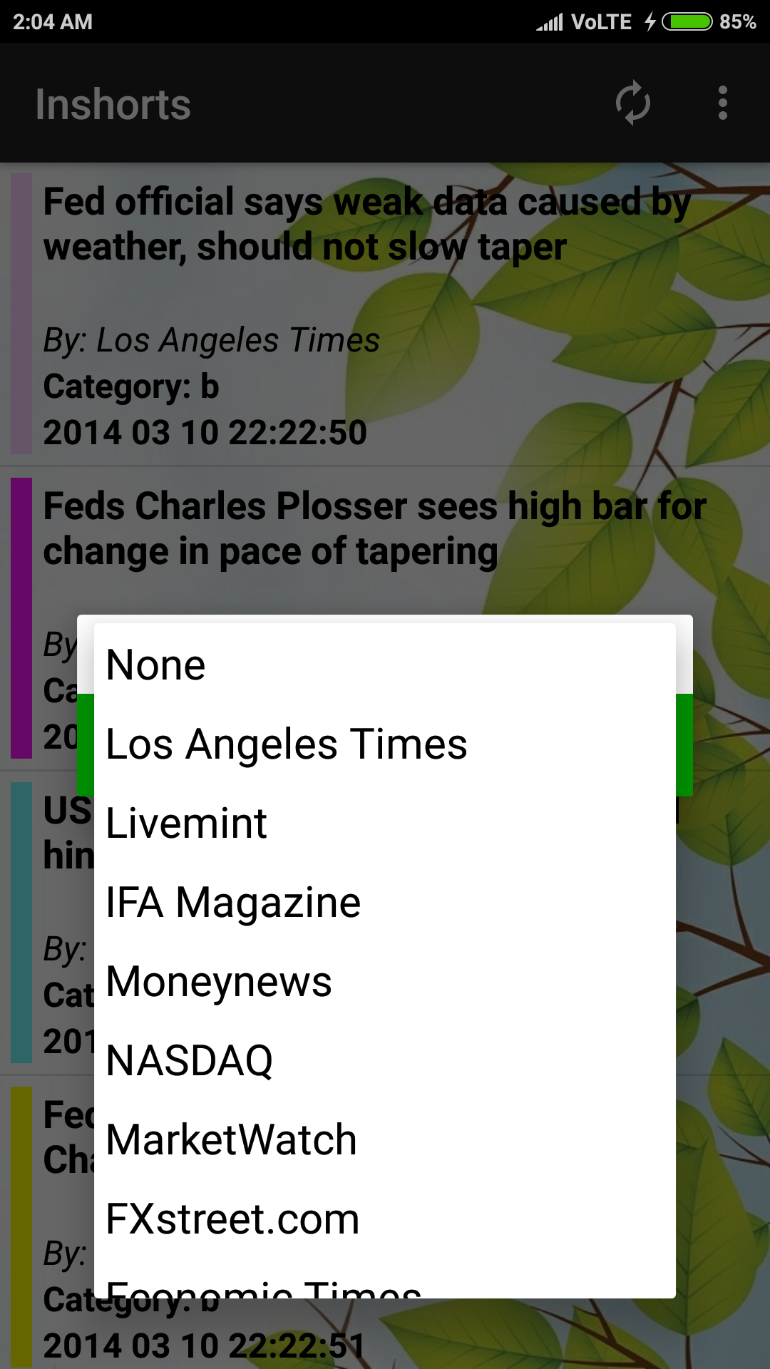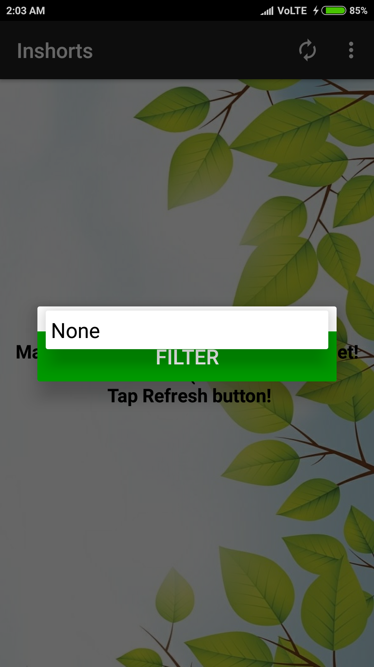

1. **Offline mode**

The offline mode is implemented using the shared preferences, the JSON is stored in the shared preferences at the time when the mobile data or the wifi is connected and internet is on.

And the offline web browsing is implemented by using cache for the webVIew (100 MB).

1. **Beautiful Design**

The UI is beautifully made, and is user friendly.